**Stakeholder Engagement Plan:**

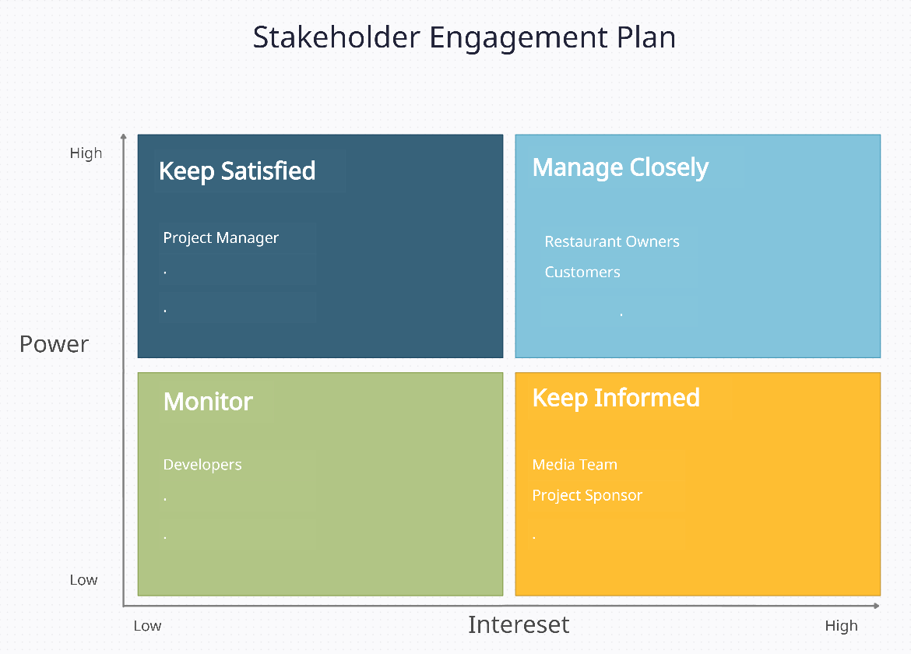

## Stakeholder Communication Plan:

|  |  |  |  |  |  |
| --- | --- | --- | --- | --- | --- |
| **Message/ Purpose** | **Responsibility** | **Audience** | **Medium** | **Content** | **Frequency/ Timing** |
| Project Status | Project Manager | Restaurant Owners | Meeting | Progress, Issues, Risks, Demo and Asking questions. | Weekly |
| Project Status | Project Manager | Customers | Meeting | Progress, Issues, Risks, Demo and Asking questions. | Weekly |
| Project updates | Team Leader | Project Manager | Meeting | Progress, Issues, Risks, Demo and Project status. | Weekly |
| Development Plan | Team Leader | Developers | Meeting | Progress, Issues, Risks, Demo, compliance and develop solutions. | Bi-Weekly |
| Marketing | Team Leader | Media Team | Email | Demo and new ideas. | Weekly |
| Financing | Project Manager | Project Sponsor | Meeting | Budget allocation and expenses. | Monthly |